Ysgol the wings to
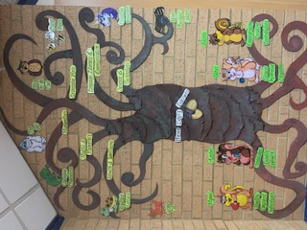
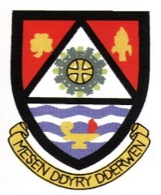

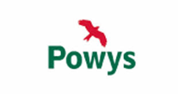
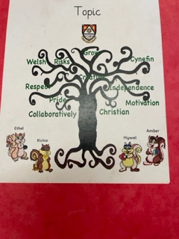
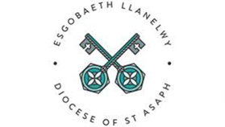

Curriculum for Wales Summary
Our curriculum has been co-constructed through engaging with all stakeholders through questionnaires to parents, governors, staff and pupils and will meet the following requirements:
Our vision

“Mesen Ddyry Dderwen”
We at Llansantffraid believe that our school works collaboratively within its community. As a Church in Wales school, a Christian ethos is at the core of our provision. With ‘Cynefin’ at its heart, being aware of our Welsh heritage, culture and language encourages a sense of pride and
respect as we grow. We promote independence and instil motivation to be creative and take risks
in our learning.

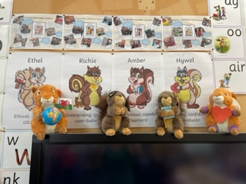
Our values
- Courage
- Perseverance
- Trust
- Responsibility
- Truthfulness
- Respect
Our inclusive curriculum
Our curriculum will raise the aspirations for all learners. As a school we have considered how all learners will be supported to realise the ambitions and aspirations of the four purposes, and to progress.

Ambitious, capable learners – we inspire all learners to aim high.

Enterprising, creative contributors – through real life, experiential learning we prepare for our future.

Ethical, informed citizens – our core values are intrinsic to everything we do and aspire to be.

Healthy, confident individuals – to be resilient and empathetic towards the health and wellbeing of ourselves and others.

The Four Purposes
The four purposes are the starting point and aspiration for our school curriculum design. Our school aims to support all learners to become:
• ambitious, capable learners, ready to learn throughout their lives
• enterprising, creative contributors, ready to play a full part in life and work
• ethical, informed citizens of Wales and the world
• healthy, confident individuals, ready to lead fulfilling lives as valued members of society
The statements of what matters Our curriculum will provide rich opportunities and authentic learning experiences to develop the key concepts, knowledge and skills as described in the statements of what matters and in line with the Statements of What Matters Code.
Areas of Learning and Experience
Our curriculum will provide learning experiences through the 6 AoLEs of:
• Languages, Literacy and Communication
• Expressive Arts
• Science and Technology
• Humanities
• Maths and Numeracy
• Health and Wellbeing

Learning, Progression and Assessment
Our curriculum will support learning through designing learning opportunities that draw upon the pedagogical principles.
Our curriculum, supported by effective learning and teaching enables learners to make meaningful progress. Over time our learners will
develop and improve their skills and knowledge. Our curriculum focuses on understanding what it means to make progress in a given Area or discipline and how learners should deepen and broaden their knowledge and understanding, skills and capacities, and attributes and dispositions and is informed by the Progression Code. This in turn supports our approach to assessment, the purpose of which is to inform planning for future learning. Assessment will be embedded as an intrinsic part of learning and teaching. All learners will be assessed on entry to the school.

Welsh and English
As an English medium school, learning will take place in English.From the early years onwards Cymraeg Ail Iaith will be taught and bilingualism modelled and promoted within and out of the classroom, during all aspects of the day and encouraging the whole school community to respect and be part of this learning. The Welsh Dimension will be at the heart of the curriculum.
Cross curricular skills
Our curriculum will develop the mandatory cross-curricular skills of literacy, numeracy and digital competence. Our curriculum will enable learners to develop competence and capability in these skills and to extend and apply them across all areas. Learners will be given opportunities across the curriculum to:
• develop listening, reading, speaking and writing skills
• be able to use numbers and solve problems in real-life situations
• be confident users of a range of technologies to help them function and communicate effectively and make sense of the world
UNCRC / UNCPRD
Our school will promote knowledge and understanding of Part 1 of the UNCRC, and of
the UNCRPD, among those who provide learning and teaching.

CWRE
Our curriculum will incorporate careers and work related experiences for all of our learners.

Headteacher:-

Chair of Governors:-

Date:- July 2022 Review Date:- July 2023

Our school curriculum embraces the RSE guidance and mandatory RSE Code. Our RSE
provision will have a positive and empowering role in our learners’ education and will play a vital role in supporting them to realise the four purposes as part of a whole-school approach. Helping learners to form and maintain a range of relationships, all based on mutual trust and respect, is the foundation of RSE. These relationships are critical to the development of emotional well-being, resilience and empathy.

Religion, values and ethics (RVE) is a statutory requirement of the Curriculum for Wales and is mandatory for all learners from ages 3 to 16.
There is no parental right to request that a child is withdrawn from RVE in the Curriculum for Wales
As RVE is a locally determined subject, the agreed syllabus specifies what should be taught in RVE within the local authority and our curriculum will reflect this guidance. As a VA school we will follow an enhanced provision of this curriculum.
Review and refinement
Our school curriculum will be kept under review in order to respond to the outputs of professional inquiry, the changing needs of learners and social contexts and needs. This will ensure our curriculum is both inclusive and responsive, meeting the needs of all learners. The reviews will take into account the views of stakeholders and will be signed off by the Governing Body and minuted. We will publish a summary of our curriculum and revise the summary if changes to the curriculum are made during the review process.

he wings

