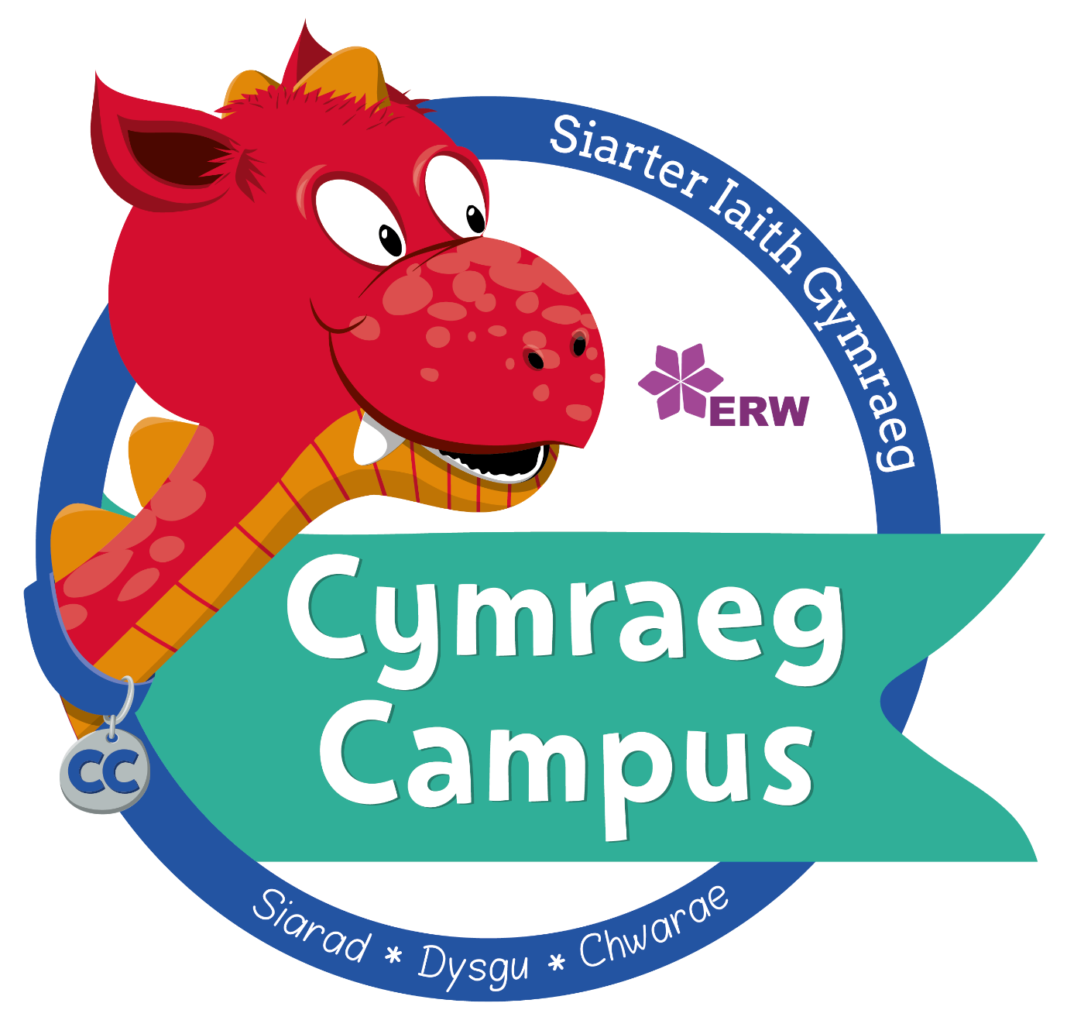

Criw Cymraeg

Croeso i dudalen y Criw Cymraeg.
The aim of this committee is to encourage and promote Cymraeg, bilingualism and a whole Welsh ethos.
Criw Cymraeg is led by Mrs Morris and pupils from Year 2 upwards who meet weekly to discuss targets for the Cymraeg Campus Bronze Award. They plan and lead a Welsh worship and generally are the team who spread the word to the rest of the school for a whole school approach.

