CLUBS
Breakfast Club  This runs daily from 8 am at the cost of £1.50 per child per day. Children are given toast/cereal/juice. No need to book. | After School Club  The club runs daily from 3.10 to 5.30 at the price of £7.00 per child Book with any member of staff.  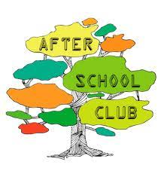
School Clubs
These vary over time and have included Sport, Running, Gardening, Craft Club, Football, Drama, Disney and Urdd. Prices are minimal to cover costs only.
