LLANSANTFFRAID
Church in Wales Primary School
www.llansantffraidprimaryschool.weebly.com
Our School Value for this half term – Respect

Our School Value for this half term -Friendship

Twitter: @SantesFfraidSch Instagram: ysgolsantesffraid Facebook: Llansantffraid Primary School
17th September
2021Parent Pack - please could any outstanding pupil contact/consent forms be returned asap. Diolch.
Ladybirds Latest

We have been busy this week starting off on our Jungle theme and cutting and painting to make display items.

Payments - Payments for clubs, dinners and Ladybirds, are through the Parentpay system. For anything else could all cash/cheques be placed in a labelled envelope and placed in the black box at the entrance or handed to a member of staff.

The Governing Body have agreed as per care provision in other schools and settings that fees need to be paid for both clubs in full by the following end of week at the latest otherwise we cannot provide spaces going forwards. Ladybirds fees are paid in advance. We make the plea as ever for outstanding debts to be paid urgently otherwise we cannot allow spaces in ANY of our extra provision – the debts will all be interlinked. We have to ensure that debts do not escalate. We thank you for your co-operation with this and apologise at this point for any difficult conversations that may need to occur.

Dydd Owain Glyndwr – 16th September annually marks the day to celebrate that this local medieval prince was declared Prince of Wales in the year 1400. His country residence of Sycharth by Llansilin is a motte and bailey castle site. Owain Glyndŵr remains one of the most heroic figures in Welsh history. His flag is popular in Wales and is flown, often side by side with Y Ddraig Goch. The day was celebrated in school with stories read and information shared about Glyndwr, his banner and his castle also using digital skills with Flipgrid to write 5 laws for Wales.

Admission to Secondary School

The Secondary School Admission Round for learners born between 01/09/2010 – 31/08/2011 opens on Monday 20 September 2021. Parents/Carers need to complete an online application at https://en.powys.gov.uk/article/1158/Applying-for-a-School-Place

Applications need to be made by the deadline of Friday 12 November 2021.

Secondary Common Offer Date is Tuesday 1 March 2022.

If a parent / carer is unable to apply online they can contact admissions@powys.gov.uk

Discovery Day – each class had a fun, hands on day to start off the term topic of ‘Celebrate Good Times’. Once we know our photo permissions, we will share the day on our social media sites.
Dosbarth Mrs Davies - The children entered a mini Mantle of the Expert project for our Discovery Day. We transformed into an expert group of party planners to solve a problem of deciding what we would need for a successful party and how to go about creating it. A cake was top of our list, so we turned our hands to baking! Following instructions, measuring, counting, working together as a team and of course the tasting … delicious! Next, we decided to create a costume for our party in the form of a hat. Repeating patterns and 2D shapes were the order of the day and we challenged ourselves to describe them to our friends. We couldn’t have a party without inviting our friends, so we created our own invitations so all of our friends knew when and where the party would take place. Our final task was to create party games and dances to enjoy during the big event, being healthy has never been so entertaining. What fun! Best party ever, even our teachers joined in! Giggles galore and memories to last until our next Discovery Day. We are now wondering where our next Mantle will take us?

Dosbarth Mrs Roberts – another class with a similar party day. This involved a range of activities – decorating biscuits, making hats, using saltdough to make party food especially decorated cupcakes. Lots of fun to enhance the learning.

Dosbarth Miss Morris – Our day was based around what we celebrate in September. To start with, the children learnt about The Great Fire of London which happened on the 2nd of September 1666. We discussed the effect of how one small problem can escalate into something big if it’s not dealt with correctly and how the people of London felt during such a scary time. The children then baked shortbread biscuits in the shape of a fire flame, working collaboratively, listening and following instructions carefully. Next, we learnt about the Chinese Moon Festival. As a class, we read an information text and then took part in a quiz to test our memory. The children were then set the challenge of designing and creating a paper lantern which is a tradition of the Chinese Moon Festival. Finally, the children looked at how we can celebrate the first day of Autumn, We looked at beautiful pictures sharing our ideas of what we could see and how Autumn made us feel. The children then created an Autumn art piece using Autumn colours and their fingertips only.

Dosbarth Mr McWhinnie - Numeracy skills were firstly used to measure an isosceles triangle. We then cut and designed in order to create celebratory bunting for the classroom. The afternoon activity was very creative in making shiny disco balls using papier mache.

Church Links
Confirmation Preparation

There will be a confirmation service for the Mission Area on 30 January 2022 and we will be beginning confirmation preparation in a few weeks time. If any adults or young people, in Year 6 or above, would be interested in being confirmed or would like to know more, please contact Revd Sarah Burton (revdsarah7@gmail.com, 01691 829116).
Online Messy Church for Harvest
We will be holding our next Messy Church on Sunday 17 October. There will be videos on the TVMA Facebook page (also available by email or USB) with activities, story and songs. Due to a grant from the Diocese we are able to provide free craft bags to accompany the Messy Church activities. If you would like to receive craft bags or would like to know more, please contact Sarah Burton (revdsarah7@gmail.com, 01691 829116).

SEPT
OCT 22nd Finish for Half Term
NOV 1st Return to school 12th Deadline application admission to Secondary
DEC 10th Theatre Severn Pantomime 22nd End of Term

Monday, 28 March 2022 |  | Pre-School Admission Round Opens
Friday, 24 | June 2022 | Pre-School Admission Round Closes
Friday, 21 | October 2022 | Pre-School Offer Date

* As this is in respect of non-statutory education, there is no right of appeal.

Monday, 4 October 2021 | Primary School Admission Round Opens
Friday, 7 January 2022 | Primary School Admission Round Closes
Tuesday,19 April 2022 | Primary Common Offer Date
Tuesday, 3 May 2022 | Latest date by which appeal must be received
Monday, 20 June 2022 | Latest date by which appeals are heard

Monday, 20 September 2021 | Secondary School Admission Round Opens
Friday, 12 November 2021 | Secondary School Admission Round Closes
Tuesday, 1 March 2022 | Secondary Common Offer Date
Monday, 21 March 2022 | Latest date by which appeal must be received
Monday, 16 May 2022 | Latest date by which appeals are heard

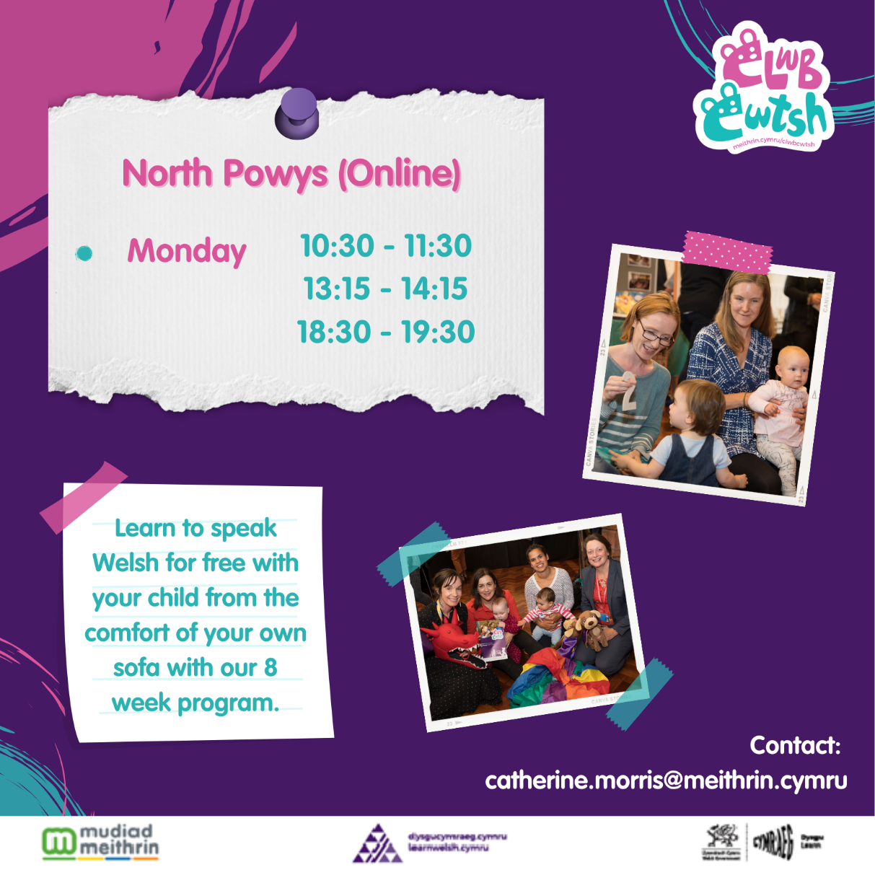

Pre-School Admission Round (Pupils Born Between 01/09/19 – 31/08/20)

